3GPP TSG-RAN WG4 Meeting #119 R4-2606025
Dalian, CHINA, May 18 - 22, 2026
Agenda item: 8.10.6
Source: CMCC
Title: Discussion on 6G testing related aspects
Document for: Discussion

Introduction
In RAN#111 meeting, use case and sensing related requirements for 6G Radio are approved.
（9）Sensing – Studies to be based on use cases and associated requirements, as defined in [TR38.914]
- PHY functions and procedures for sensing technology (e.g., waveform. reference signals, measurement feedback, etc…) [RAN1, RAN4]
- Evaluate sensing performance and if necessary, extend channel modelling, for the selected use cases [RAN1]
- Aspects of integration with communication services [RAN1]
- higher layer procedures and protocol aspects [RAN2]
- RAN4 aspects of sensing including RF, coexistence, and testability in coordination with other WGs [RAN4]
Note: RAN1 identify detailed requirements, if triggered by TSG RAN

According to chairman’s guideline, the scope of sensing includes RAN4 related PHY functions and procedure, RF, coexistence and testability. According to moderator’s suggestion, this agenda will include both TRP side and UE side testing.
From our understanding, now there is even no any conclusion of performance metric for each requirement, no conclusion of which requirements are needed. It’s a little early to discuss the testing framework. Following we just list the candidate issues that is new and needs further study based on conclusion of requirements discussion.
This contribution gives our proposals on 6G sensing testing.

Discussion

2.1 TRP side testing
In sensing applications, higher frequencies typically yield reduced clutter and superior overall performance. Conversely, longer wavelengths (lower frequencies) are subject to stronger scattering, complex multipath effects, and more severe Doppler dispersion. While they offer wider coverage, they also suffer from a more congested spectrum and diminished spatial domain suppression.
These factors result in significant overlap between clutter and target echoes, leading to a collapse of the Signal-to-Noise Ratio (SNR) and a marked degradation in sensing accuracy. Consequently, higher frequency bands are preferred for sensing. To support this requirement, both 1-H (Hybrid) and 1-O (Over-the-Air) TRP (Transmission Reception Point) configurations are recommended, encompassing both conducted and OTA testing methodologies.

Proposal 1: for TRP side testing, 1-H and 1-O TRP are suggested including both conducted and OTA testing.
Following list the RAN plenary approved sensing related requirements, they are much different from what is used in legacy gNB testing framework, which will finally contribute to different testing framework. Since now there is no concrete agreements for final sensing related requirements or finally RF requirements, following just list the candidate new issues that needs to be resolved for sensing.

5.1.17 Sensing-related requirements
Sensing-related capabilities are measured in terms of the following technical performance requirements:
• Detection Probability and False Alarm Probability: Detection probability is the probability of correctly detecting the presence of the sensing target when it is present, and false alarm probability is the associated probability that a sensing target is detected when no corresponding true sensing target is present.
• Horizontal/Vertical Localization Accuracy: It is defined as the absolute difference between the estimated horizontal/vertical location and the actual horizontal/vertical location of the sensing target. The value of localization accuracy shall be obtained assuming 90% confidence level, which is the 90th percentile point of the CDF of the location estimation error. Both the horizontal and vertical localization accuracy are estimated based on Cartesian coordinates.
• Velocity Accuracy: It is defined as the absolute difference between the estimated velocity and the actual velocity of the sensing target. The value of velocity accuracy shall be obtained assuming 90% confidence level, which is the 90th percentile point of the CDF of the velocity estimation error.
In the above technical performance requirements, the sensing target is a passive object, which is not connected to the radio network for communication.
The minimum requirements for Sensing-related requirements are summarized in Table 5.1.17-1.
Table 5.1.17-1: Sensing-related requirements
 | Indoor Factory | Urban Macro
Detection Probability | 95% | 95%
False Alarm Probability | 5% | 5%
Horizontal Localization Accuracy | 2 m | 5 m
Vertical Localization Accuracy | N/A | 8 m (Note 1)
Velocity Accuracy | 2 m/s | 4 m/s
Note 1: The applicability of vertical localization accuracy depends on the type of sensing target.

Different from SNR/throughput requirement, all above five requirements will be significant impacted by the signal reflection. For all OTA testing, we need to make sure there is no reflection into the testing. For BS using higher frequency, the aperture of BS is much larger which will contribute to larger diameter of testing environment size, e.g. 50-60m for 4.9GHz. based on our survey in 5GA, there is no such large testing environment without reflection. For 6GR, it’s suggested to at first find out whether and how to test Rx sensing signal without any reflection to avoid candidate impact from reflection to above four requirements.
Observation 1: different from SNR/throughput testing, the reflection in testing environment will have significantly negative impact for following five sensing related requirements.
- Detection Probability
- False Alarm Probability
- Horizontal Localization Accuracy
- Vertical Localization Accuracy
- Velocity Accuracy
Proposal 2: RAN4 is suggested to study whether and how to testing above five sensing related OTA Rx requirements in the environment without any reflection, i.e. only pure LOS signal.
Another issue is about the sensing signal, following list the candidate sensing signals proposed in last meeting.
 | Pulse Wave (PW) Radar | Continuous Wave (CW) Radar
Time Domain characteristic | 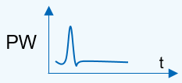  Or 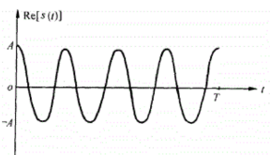 | 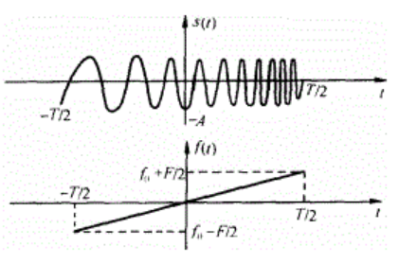
Frequency Domain  Characteristic | 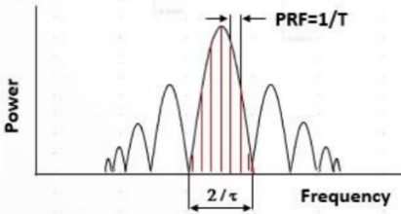 | 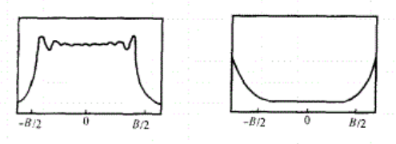
Time-Bandwidth Product (TBP) | $$τ×B=1$$ | $$τ×B>1$$
Operating State of the transmitter PA | Saturation State for larger output power | Saturation State or linear State due to large TBP
Duplex Mode | The operation of transmission and receiving is in the Time Division Duplex (TDD). | The operation of transmission and receiving is in the Full Duplex at the same time and frequency (bandwidth).
Self-interference | As TDD is used for transmission and receiving, there is no self-interference issue. | There is a strong receiving self-interference coupled from transmitter. Generally, the methods of moving target detection technology should be used to eliminate the self-interference, e.g. self-heterodyne, Pulse-Doppler Method.
Range Blind Zone | cτ/2 | If Full Duplex Operation between transmission and receiving is used, there is no Range Blind Zone for CW Radar.
Pulse Compression | Not supported | Supported. For example, matched filter is used to complete the Pulse Compression for LMF signal, but the side lobe of strong Object may interfere the detection of the small Object.

In mono-static sensing, both pulsed and continuous wave (CW) waveforms are essential to balance coverage and interference. Due to inherent self-interference (SI) limitations in co-located transceiver architectures, CW transmission is power-constrained (e.g., limited to 35 dBm), which restricts the effective detection and tracking range. To extend this range, pulsed waveforms are necessary as they allow for significantly higher output power (e.g., 59 dBm). By utilizing Time Division Multiplexing (TDM) between Tx and Rx, pulsed sensing effectively bypasses severe self-interference.
In contrast, bi-static sensing can circumvent complex self-interference cancellation algorithms because the spatial separation between the transmitter and receiver provides natural isolation. This isolation allows CW to be transmitted at higher power levels without compromising the receiver's dynamic range. Consequently, CW alone may be sufficient for bi-static modes to achieve both wide coverage and manageable interference levels.
Observation 2: For mono-static sensing, a hybrid approach using both pulsed and continuous waves is necessary. Pulsed waves enable high-power transmission for long-range detection via TDM-based SI avoidance. Complementarily, low-power continuous waves are used for short-range sensing where self-interference remains within acceptable limits.
Observation 3: For bi-static sensing, continuous wave transmission is sufficient. The inherent spatial isolation between the Tx and Rx nodes allows for high-power CW transmission, achieving extensive coverage while minimizing self-interference.
Proposal 3: It is proposed that RAN4 further evaluate the feasibility of utilizing only continuous waves for bi-static testing, and the feasibility of utilizing both pulsed and continuous wave support for mono-static sensing configurations.

2.2 UE testing
The same issue as TRP side, when UE is used as the receiver, i.e. UE-UE mono-static, BS-UE bi-static, the testing should be implemented in the environment without any reflection. It seems the same Anechoic Chamber used in OTA testing can be considered as baseline.
Proposal 4: to avoid reflection impact, the anechoic chamber used in OTA UE testing can be referred as baseline for the sensing mode when UE is used as receiver.
- Conclusion
In this contribution, we have following observation and proposals.
Proposal 1: for TRP side testing, 1-H and 1-O TRP are suggested including both conducted and OTA testing.

Observation 1: different from SNR/throughput testing, the reflection in testing environment will have significantly negative impact for following five sensing related requirements.
- Detection Probability
- False Alarm Probability
- Horizontal Localization Accuracy
- Vertical Localization Accuracy
- Velocity Accuracy

Proposal 2: RAN4 is suggested to study whether and how to testing above five sensing related OTA Rx requirements in the environment without any reflection, i.e. only pure LOS signal.
Observation 2: For mono-static sensing, a hybrid approach using both pulsed and continuous waves is necessary. Pulsed waves enable high-power transmission for long-range detection via TDM-based SI avoidance. Complementarily, low-power continuous waves are used for short-range sensing where self-interference remains within acceptable limits.
Observation 3: For bi-static sensing, continuous wave transmission is sufficient. The inherent spatial isolation between the Tx and Rx nodes allows for high-power CW transmission, achieving extensive coverage while minimizing self-interference.
Proposal 3: It is proposed that RAN4 further evaluate the feasibility of utilizing only continuous waves for bi-static testing, and the feasibility of utilizing both pulsed and continuous wave support for mono-static sensing configurations.
Proposal 4: to avoid reflection impact, the anechoic chamber used in OTA UE testing can be referred as baseline for the sensing mode when UE is used as receiver.

- Reference
- RP-251395, Revised SID: Study on 6G Scenarios and requirements, 3GPP TSG RAN Meeting #108Prague, Czech Republic, June 9-13, 2025.
- RP-251881, New SID: Study on 6G Radio, 3GPP TSG RAN Meeting #108Prague, Czech Republic, June 9-13, 2025.
- RP-252088
- Minimum requirements related to technical performance for IMT-2030 radio interface(s), 2 July 2025
- R4-2514592, WF on 6G sensing, ZTE

